

OBJECT ORIENTED PROGRAMMING
(Lab No. 5)

Name : Muhammad Usman Ahmad Wattoo.
Reg. No. : SP25-BCS-076.
Section : BCS-2B.

Submitted to
Ms. Sajda Kalsoom

Lab Task 1
Create an Address class, which contains street#, house#, city and code. Create another class Person that contains an address of type Address. Give appropriate get and set functions for both classes. Test class person in main.

- CODE:
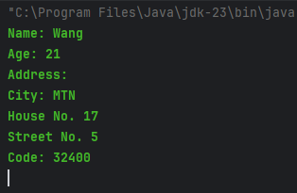
class Address{
private int street;
private int house;
private String city;
private int code;
public Address(){
street = 0;
house = 0;
city = "";
code = 0;
}
public Address(int s, int h, String ct, int c){
street = s;
house = h;
city = ct;
code = c;
}
public int getCode() {
return code;
}
public void setCode(int c) {
code = c;
}
public String getCity() {
return city;
}
public void setCity(String ct) {
city = ct;
}
public int getHouse() {
return house;
}
public void setHouse(int h) {
house = h;
}
public int getStreet() {
return street;
}
public void setStreet(int s) {
street = s;
}
public void display(){
System.out.println("City: " + city);
System.out.println("House No. " + house);
System.out.println("Street No. " + street);
System.out.println("Code: " + code);
}
}
class Person{
private String name;
private int age;
private Address ad;
public Person(){
name = "";
age = 0;
ad = new Address();
}
public Person(String n, int a, Address add){
name = n;
age = a;
ad = add;
}
public String getName() {
return name;
}
public void setName(String n) {
name = n;
}
public Address getAd() {
return ad;
}
public void setAd(Address add) {
ad = add;
}
public int getAge() {
return age;
}
public void setAge(int a) {
age = a;
}
public void display(){
System.out.println("Name: " + name);
System.out.println("Age: " + age);
System.out.println("Address: ");
ad.display();
}
}
public class Task1{
public static void main(String[] args) {
Address A = new Address(5, 17, "MTN", 32400);
Person P1 = new Person("Wang", 21, A);
P1.display();
}
}
- OUTPUT:
Name: Wang
Age: 21
Address:
City: MTN
House No. 17
Street No. 5
Code: 32400

Lab Task 2
Create a class Book that contains an author of type Person (Note: Use the Person class created in the first exercise). Other data members are bookName and publisher. Modify the address of the author in runner class.

- CODE:
class Book{
private String name;
private String publisher;
private Person author;
public Book(){
name = "";
publisher = "";
author = new Person();
}
public Book(String n, String pb, Person ath){
name = n;
publisher = pb;
author = ath;
}
public String getName() {
return name;
}
public void setName(String n) {
name = n;
}
public String getPublisher() {
return publisher;
}
public void setPublisher(String pb) {
publisher = pb;
}
public Person getAuthor() {
return author;
}
public void setAuthor(Person ath) {
author = ath;
}
public void display(){
System.out.println("The author of the book name " + name + " by publisher " + publisher + " is ");
author.display();
}
}
public class Task2 {
public static void main(String[] args) {
System.out.println("Before Updating Address,");
Address A1 = new Address(5, 17, "MTN", 32400);
Person ath1 = new Person("Honda", 24, A1);
Book B1 = new Book("CAR", "Printer" ,ath1);
B1.display();
System.out.println();
System.out.println("After Updating Address,");
Address A2 = new Address(10, 27, "BWP", 32200);
B1.getAuthor().setAd(A2);
B1.display();
}
}
- OUTPUT:
Before Updating Address,
The author of the book name CAR by publisher Printer is
Name: Honda
Age: 24
Address:
City: MTN
House No. 17
Street No. 5
Code: 32400

After Updating Address,
The author of the book name CAR by publisher Printer is
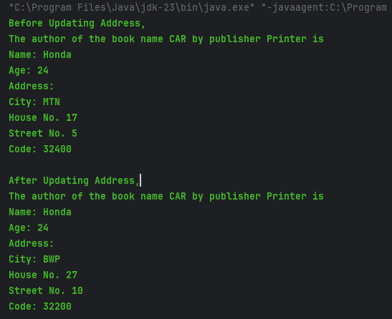
Name: Honda
Age: 24
Address:
City: BWP
House No. 27
Street No. 10
Code: 32200

Lab Task 3
Design a class Point with two data members x-cord and y-cord. This class should have an arguments constructor, setters, getters and a display function.
Now create another class ―Line‖, which contains two Points ―startPoint‖ and ―endPoint‖. It should have a function that finds the length of the line.
Hint: formula is: sqrt((x2-x1)2 + (y2-y1)2)
Create two line objects in runner and display the length of each line.

- CODE:
class Pointer{
private int xcord;
private int ycord;
public Pointer(){
xcord = 0;
ycord = 0;
}
public Pointer(int x, int y){
xcord = x;
ycord = y;
}
public int getXcord() {
return xcord;
}
public int getYcord() {
return ycord;
}
public void setYcord(int y) {
ycord = y;
}
public void setXcord(int x) {
xcord = x;
}
public void display(){
System.out.println("X-Cord is " + xcord);
System.out.println("Y-Cord is " + ycord);
}
}
class Line{
private Pointer startPoint;
private Pointer endPoint;
public Line(){
startPoint = new Pointer();
endPoint = new Pointer();
}
public Line(Pointer sp, Pointer ep){
startPoint = sp;
endPoint = ep;
}
public Pointer getStartPoint() {
return startPoint;
}
public Pointer getEndPoint() {
return endPoint;
}
public void setEndPoint(Pointer ep) {
endPoint = ep;
}
public void setStartPoint(Pointer sp) {
startPoint = sp;
}
public double findLength(){
return Math.sqrt((Math.pow((endPoint.getXcord() - startPoint.getXcord()), 2) + Math.pow((endPoint.getYcord() - startPoint.getYcord()), 2)));
}
public void display(){
System.out.println("The Starting Point of the line is ");
startPoint.display();
System.out.println("The Ending Point of the line is ");
endPoint.display();
}
}
public class Task3 {
public static void main(String[] args) {
Pointer P1 = new Pointer(2, 3);
Pointer P2 = new Pointer(3, 2);
Line l1 = new Line(P1, P2);
System.out.println("The length of the line 1 is " + l1.findLength());
System.out.println();
Pointer P3 = new Pointer(7, 15);
Pointer P4 = new Pointer(9, 3);
Line l2 = new Line(P3, P4);
System.out.println("The length of the line 2 is " + l2.findLength());
}
}
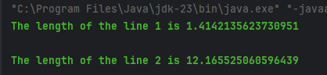
- OUTPUT:
The length of the line 1 is 1.4142135623730951

The length of the line 2 is 12.165525060596439

Lab Task 3
Create a class named Pizza that stores information about a single pizza. It should contain the following: 42

Private instance variables to store the size of the pizza (either small, medium, or large), the number of cheese toppings, the number of pepperoni toppings, and the number of ham toppings.
Constructor(s) that set all of the instance variables.
Public methods to get and set the instance variables.
A public method named calcCost( ) that returns a double that is the cost of the pizza. Pizza cost is determined by:
Small: $10 + $2 per topping Medium: $12 + $2 per topping Large: $14 + $2 per topping
public method named getDescription( ) that returns a String containing the pizza size, quantity of each topping.
Write test code to create several pizzas and output their descriptions. For example, a large pizza with one cheese, one pepperoni and two ham toppings should cost a total of $22.
Now Create a PizzaOrder class that allows up to three pizzas to be saved in an order. Each pizza saved should be a Pizza object. Create a method calcTotal() that returns the cost of order.
In the runner order two pizzas and return the total cost.

- CODE:
class Pizza{
private String size;
private int cheese;
private int pepperoni;
private int ham;
public Pizza(){
size = "";
cheese = 0;
pepperoni = 0;
ham = 0;
}
public Pizza(String s, int c, int p, int h){
size = s;
cheese = c;
pepperoni = p;
ham = h;
}
public String getSize() {
return size;
}
public void setSize(String s) {
size = s;
}
public int getCheese() {
return cheese;
}
public void setCheese(int c) {
cheese = c;
}
public int getPepperoni() {
return pepperoni;
}
public void setPepperoni(int p) {
pepperoni = p;
}
public int getHam() {
return ham;
}
public void setHam(int h) {
ham = h;
}
public double calCost(){
double cost = 0;
if (size.equalsIgnoreCase("Small")) {
cost = 10;
for(int i = 0; i < (cheese + pepperoni + ham); i++){
cost += 2;
}
}else if (size.equalsIgnoreCase("Medium")) {
cost = 12;
for(int i = 0; i < (cheese + pepperoni + ham); i++){
cost += 2;
}
}else if (size.equalsIgnoreCase("Large")) {
cost = 14;
for(int i = 0; i < (cheese + pepperoni + ham); i++){
cost += 2;
}
}
return cost;
}
public String getDescription(){
String description = "You ordered a " + size +" Pizza with " + cheese + " Chesse, " + pepperoni + " Pepperoni and " + ham +" Ham";
return description;
}
}
class PizzaOrder{
private Pizza pizza1;
private Pizza pizza2;
private Pizza pizza3;
public PizzaOrder(){
pizza1 = new Pizza();
pizza2 = new Pizza();
pizza3 = new Pizza();
}
public PizzaOrder(Pizza p1, Pizza p2){
pizza1 = p1;
pizza2 = p2;
}
public PizzaOrder(Pizza p1, Pizza p2, Pizza p3){
pizza1 = p1;
pizza2 = p2;
pizza3 = p3;
}
public Pizza getPizza1() {
return pizza1;
}
public void setPizza1(Pizza p1) {
pizza1 = p1;
}
public Pizza getPizza2() {
return pizza2;
}
public void setPizza2(Pizza p2) {
pizza2 = p2;
}
public Pizza getPizza3() {
return pizza3;
}
public void setPizza3(Pizza p3) {
pizza3 = p3;
}
public double calCost(){
double tcost = 0;
if (pizza1 != null) {
tcost += pizza1.calCost();
}
if (pizza2 != null) {
tcost += pizza2.calCost();
}
if (pizza3 != null) {
tcost += pizza3.calCost();
}
return tcost;
}
}
public class Task4 {
public static void main(String[] args) {
Pizza p1 = new Pizza("Large", 1, 1, 2);
Pizza p2 = new Pizza("Medium", 3, 0, 4);
System.out.println("Bill: " + p1.calCost());
System.out.println("Description: " + p1.getDescription());
System.out.println("Bill: " + p2.calCost());
System.out.println("Description: " + p2.getDescription());
System.out.println();
PizzaOrder o1 = new PizzaOrder(p1, p2);
System.out.println("Total Bill is: " + o1.calCost());
}
}
- OUTPUT:
Bill: 22.0
Description: You ordered a Large Pizza with 1 Chesse, 1 Pepperoni and 2 Ham
Bill: 26.0
Description: You ordered a Medium Pizza with 3 Chesse, 0 Pepperoni and 4 Ham
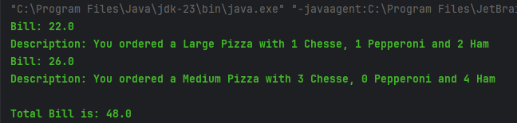
Total Bill is: 48.0

(THE END)

